1. Open ShopPAK  
   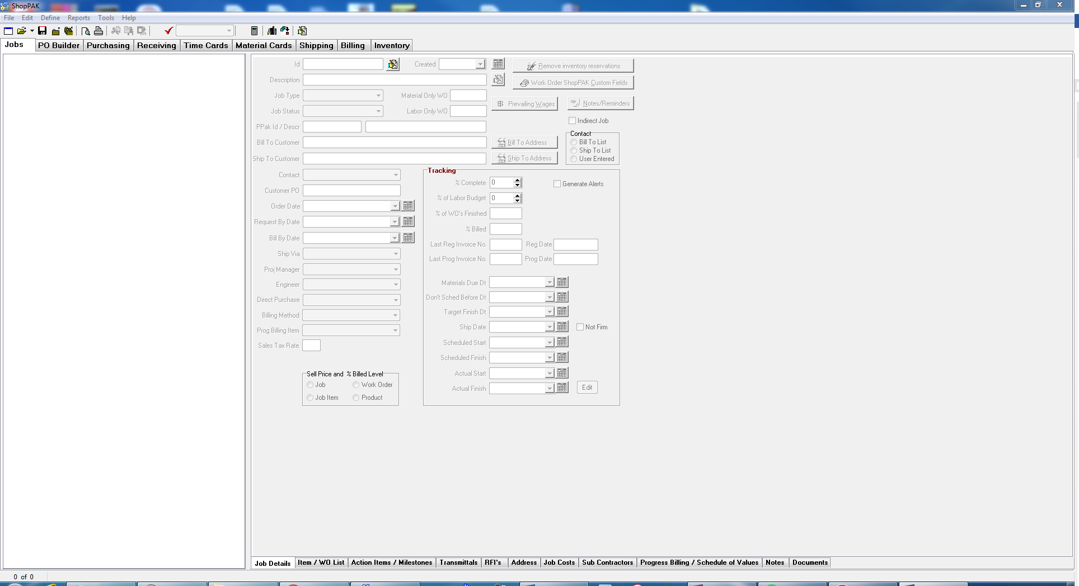
2. Open Job that needs to have Milestones Assigned  
   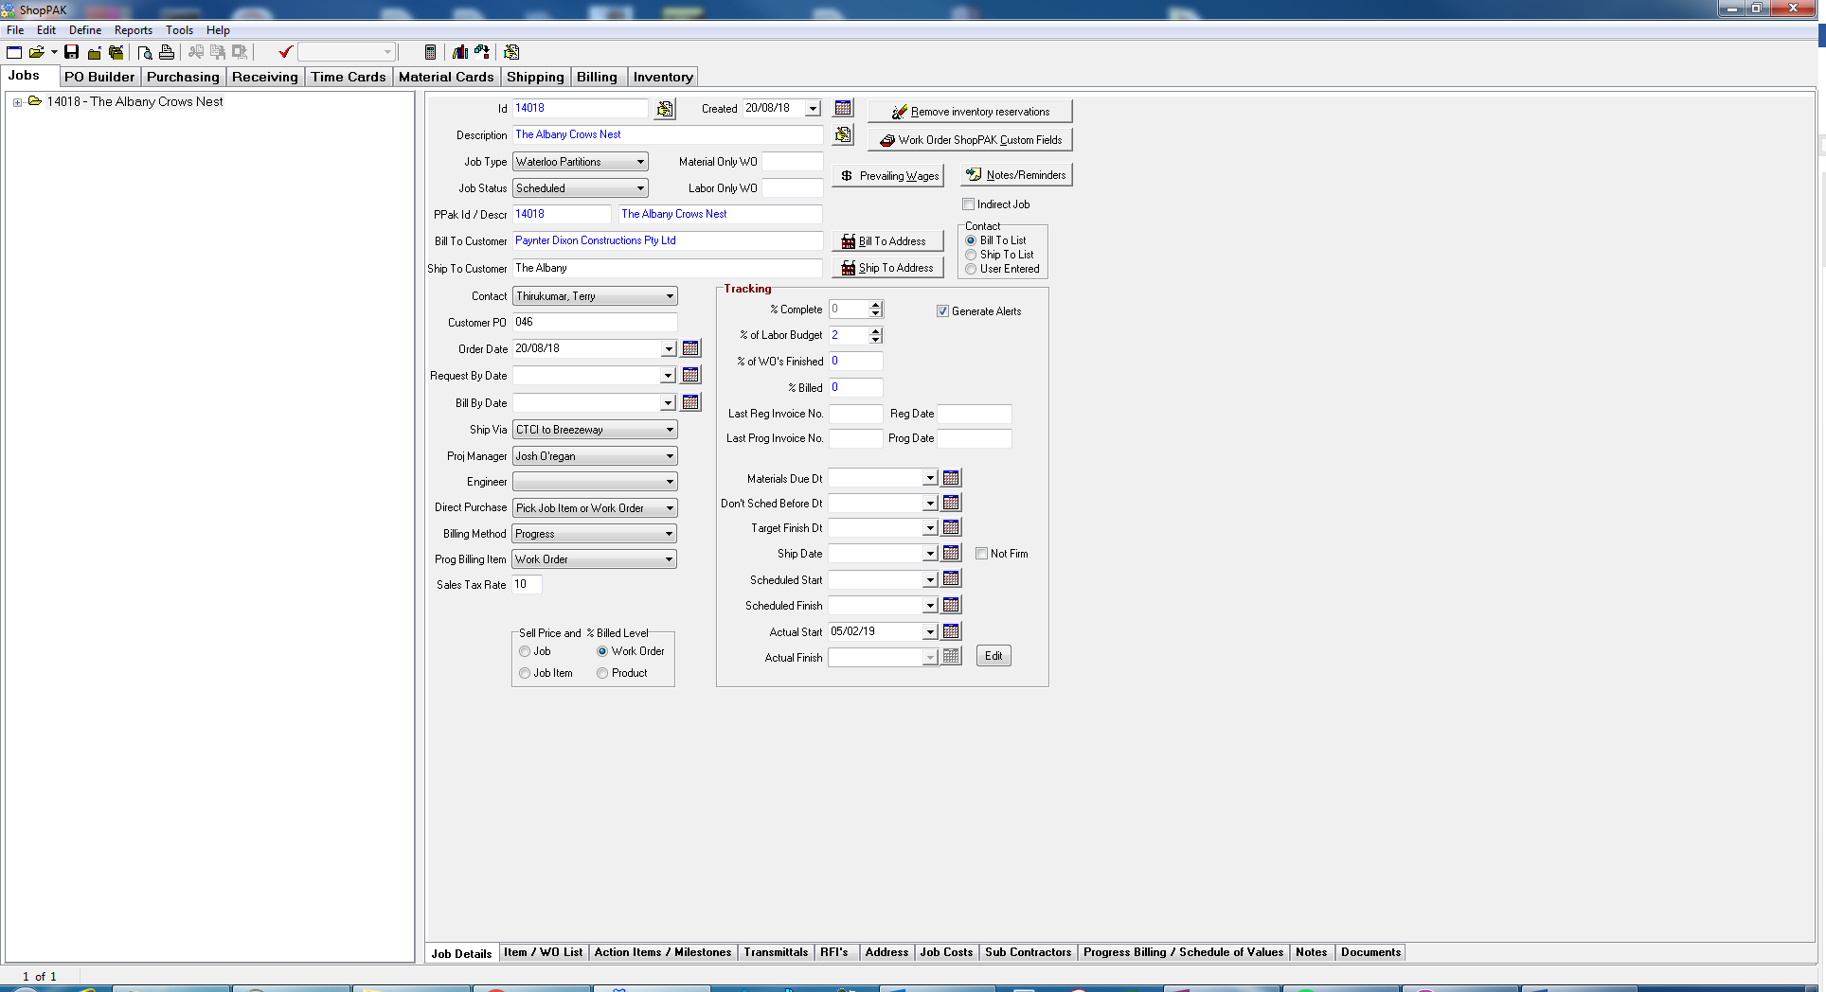
3. Open Action Items / Milestones tab  
   
4. Ensure that the milestones have been selected at the Work Order level.  
   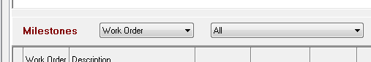
5. Left click on top of Milestones grid to open menu  
   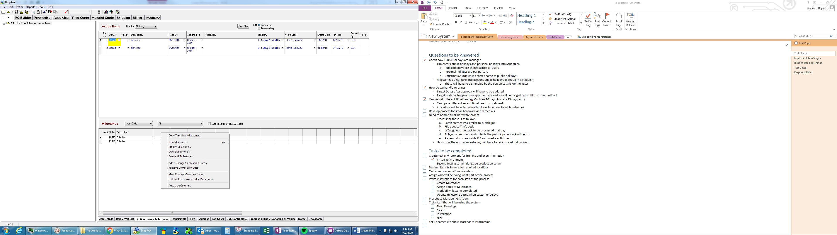
6. Select Copy Milestones Template  
   
7. Select the Cubicles, with yes in the scoreboard column. It is important to select the correct template as Scoreboard will only recognize one template  
   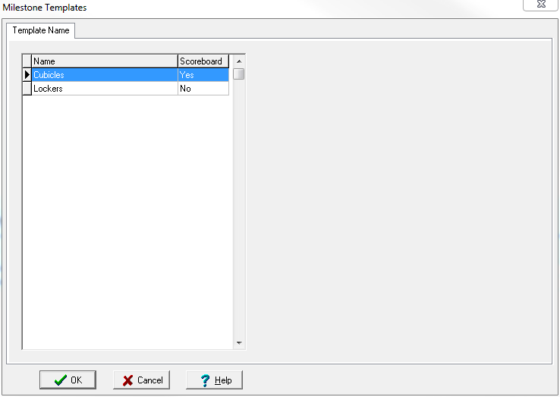
8. Milestones have been populated, ready for dates to be set.  
   